Instructions for Preparing the Abstract of the International Workshop on Microcavities and Their Applications

Keiji Sasaki¹, Hideki Fujiwara¹, Kyosuke Sakai¹, and Shutaro Ishida²
¹Research Institute for Electronic Science, Hokkaido University, Sapporo, Hokkaido, 001-0020 Japan
²Department of Applied Physics, Osaka University, Suita, Osaka, 565-0871 Japan
Tel: (81) 11 706 9396, Fax: (81) 11 706 9390, e-mail: secretariat@woma2015.com
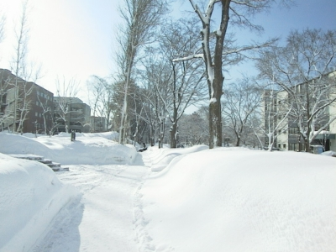Fig 1. Caption
In this paper, instructions for preparation of an abstract for International Workshop on Microcavities and Their Applications are presented. This document contains information about formats, fonts and sizes of the abstract. Color figures can be included. The abstract is limited to one page but must have at least 200 words in English. It should contain what was done, how it was done, and what is the main result and why it is important. The abstract should be prepared using Microsoft Word and converted to a PDF file. File name should be “(Last name)(First name)”, for example, “sasakikeiji.docx” and “sasakikeiji.pdf”. Both MS-WORD and PDF files must be submitted on the on-line submission page of the WOMA2015 website (http://www.woma2015.com/abstract.html). If you have any questions, please contact the secretariat of WOMA2015 (secretariat@woma2015.com).

Keywords: keywords describing your paper here, e.g.: laser, cavity, scar

